**Aim:** To implement Bresenham’s algorithms for drawing a line segment between two given end points.

**Objective:**

Draw a line using Bresenham's line algorithm that determines the points of an n-dimensional raster that should be selected to form a close approximation to a straight line between two points

**Theory:**

In Bresenham’s line algorithm pixel positions along the line path are obtained by determining the pixels i.e. nearer the line path at each step.

**Algorithm -**

{

x=x1;

y=y1;

 dx=x2-x1;

 dy=y2-y1;

 p=2*dy-dx;

while(x1<=x2)

{

 putpixel(x1,y1,RED);

 x1++;

 if(p<0)

{

 p=p+2*dy;

 }

else

{

p=p+2*dy-2*dx;

y1++;

}

}

**Program -**

#include<stdio.h>

#include<conio.h>

#include<graphics.h>

#include<math.h>

#include<dos.h>

void main()

{

 clrscr();

 int gd=DETECT, gm;

 int x1,y1,x2,y2,dx,dy,p;

  initgraph(&gd,&gm,"C:\\TURBOC3\\BGI");

 printf("Enter x1,y1s:\n");

 scanf("%d %d",&x1,&y1);

 printf("Enter x2,y2:\n");

 scanf("%d %d",&x2,&y2);

 dx=x2-x1;

 dy=y2-y1;

 p=2*dy-dx;

while(x1<=x2){

 putpixel(x1,y1,50);

 x1++;

 if(p<0){

 p=p+2*dy;

 }

else

{

p=p+2*dy-2*dx;

y1++;

}

}

getch();

closegraph();

}

**Output –**

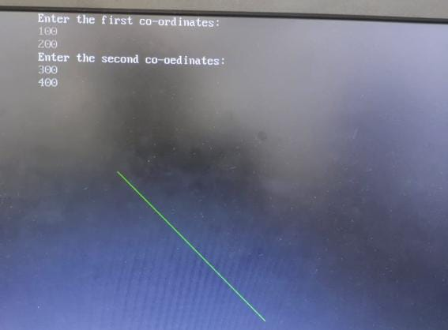

**Conclusion:** Comment on -

1. Pixel-The term "pixel" is short for "picture element." It is the smallest unit of an image or graphics displayed on a digital screen.
2. Equation for line -y=mx+c
3. Need of line drawing algorithm-1)Efficiency2)Straight-line drawing3)Rasterization4)Hardware implementation5)Straight line approximation6)Learning and understanding
4. Slow or fast-FFast